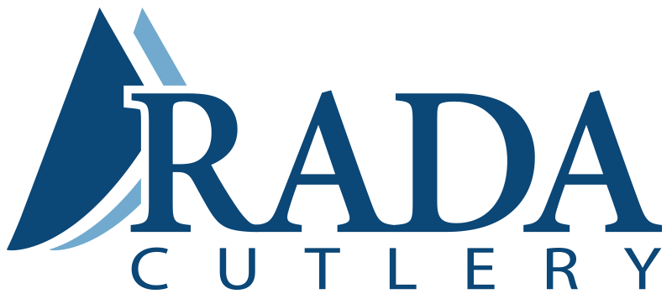

Rada Manufacturing Co
CustomerService@RadaMfg.com
Rada Mfg. Co., PO Box 838,
Waverly, IA 50677
1-319-352-5454

This is the Rada Online Marketing Team,

We are helping out this fundraising group by supplying the products for them to sell. They are selling Rada Cutlery’s 100% Made in the USA kitchen products to raise money for their group.
Our goal is that by providing the group a link to post - one that will be provided at the bottom of this letter - it will make it much easier for you - the community - to purchase from and support your local groups.
Please click on this link: [insert your group’s personalized link] to start shopping.
By clicking this link, you will be moved to Rada’s Online Fundraising website and all purchases made for 365 days will automatically be attributed to the account of the group whose link you clicked. Thank you again for supporting your community,
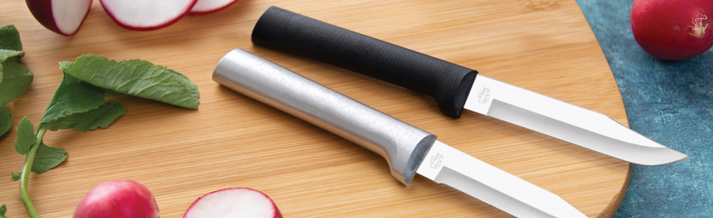
Best,
Rada Mfg Co.

